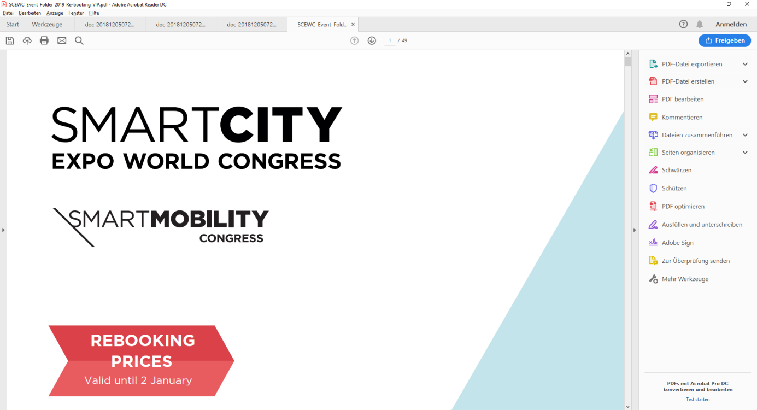**Application Document – Provisional / Internal use only**

**Commercial information:**

•         Commercial name:

•         Address:

•         Post Code:

•         Town:

•         Province:

•         Country:

•         Phone:

•         Web:

**Person in charge for exhibition:**

•         Name:

•         Position:

•         Mobile:

•         Mail:

**Invoice information:**

•         Person in charge for contract and payment details:

•         Mail:

•         Phone:

•         Address:

•         Company VAT:

**Presencial**

**Sector: ( ) Digital Transformation ( ) Urban Environment ( ) Mobility**

**( ) Governance & Finance ( ) Inclusive & Sharing Cities**

**Packs: ( ) 12m²-Bronze ( ) 16-24m² Silver ( ) 35m²-Gold**

**Space: ( ) Space Only / Own booth**

**( ) 35m² ( ) 70m² ( ) 100m² ( ) 120m² ( ) 140m² ( ) 310m² ( ) + 310m²**

**( ) Other**

**Partnership:** **( ) Event Partner ( ) Industry Partner ( ) Global Partner**

**Digital**

**Tomorrow.City: _____________**

Name: Place, Date: